# Conditional Formatting in Power BI

Conditional formatting in Power BI allows to visually highlight data based on business rules or logic. It enhances the readability of dashboards and helps users identify key trends, outliers, and patterns.



## Types Conditional Formatting:

Conditional formatting in Power BI lets you apply formatting to visuals based on the data’s value. This helps in quickly identifying trends, patterns, or outliers.

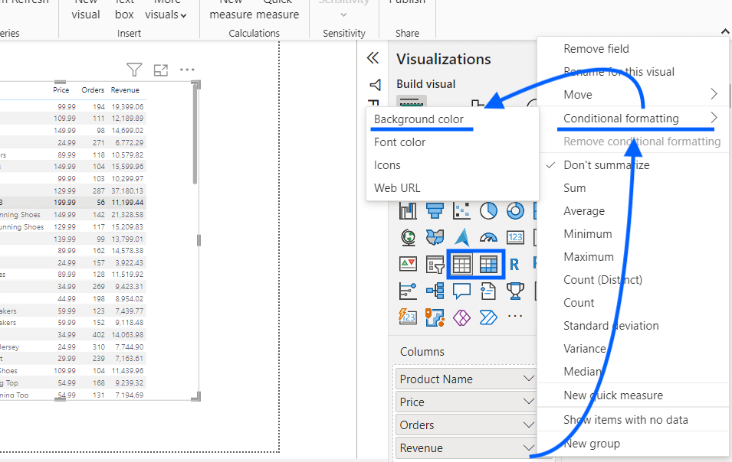

**1. Background Color Formatting**

* Changes the background color of a cell or data point based on values.
* **Example:** Sales below target are red; above target are green.

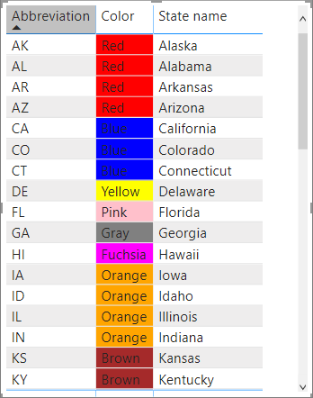

**2. Font Color Formatting**

* Changes the **text color** based on values or rules.
* Useful to highlight high-risk or high-value items.

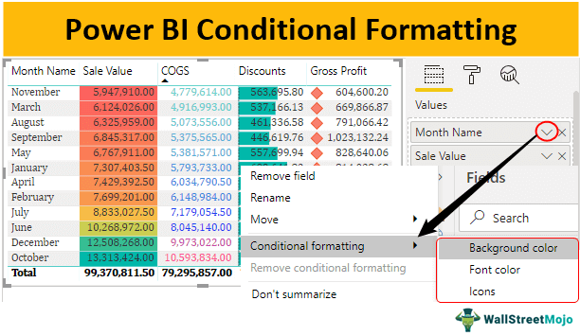

**3. Data Bars**

* Displays bars **inside table/matrix cells** to show relative values visually.
* Similar to Excel’s in-cell bar charts.

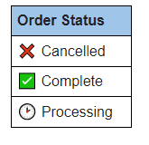

**4. Icons (Field Value Icons)**

* Adds visual indicators (like arrows, flags, or check marks).
* Useful for KPIs or status indicators (e.g., ↑ for growth, ↓ for decline).

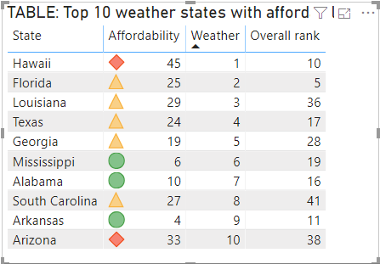

**5. Web URL Formatting**

* Makes a column's text clickable as a **hyperlink**.
* Great for linking to external documents, images, or reports.

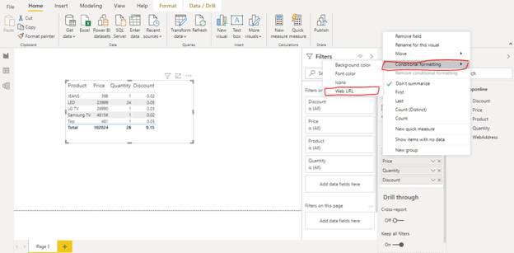

**6. KPI Indicators**

* Visual indicators tied to a measure that evaluates performance against a goal.
* Often includes colors, shapes, and arrows based on threshold logic.
* 

FILTERS

KPI’S

Visualization : **clustered Bar Chart**. Displays the city along with the city name and axis type

Dashboard page which displays the overview of the **ZOMATO**

YEAR WISE FILTER UPTO 2017,2018,2019,2020

Image displays about the Zomato with filter like **VEG , NON-VEG , OTHERS**

**GUAGE** visualization tells the **TOTAL NUMBER OF ORDERS.**

**7. Based on Field Values**

* Uses another column (typically a calculated one) to control formatting.
* Example: A column named ColorCode with values like "Red", "Green", used to apply background color.

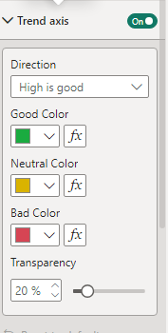

**1. IF Function**

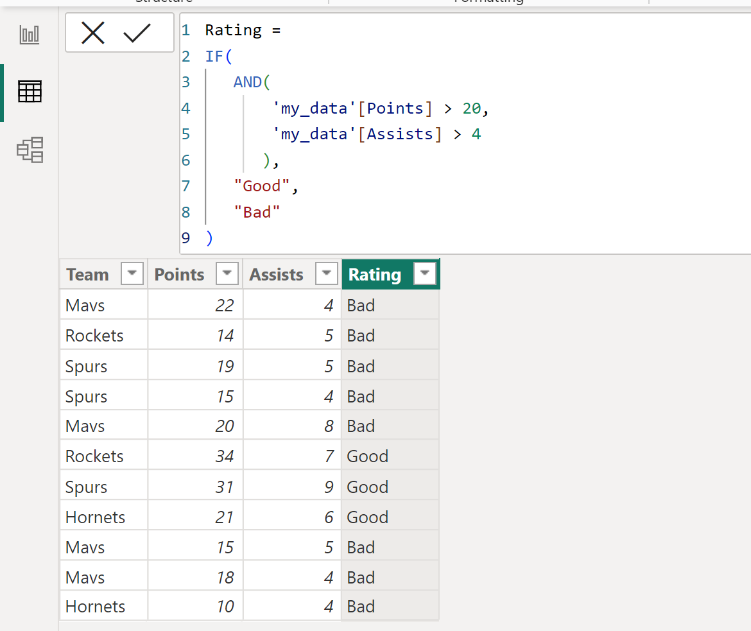

**2. SWITCH Function**

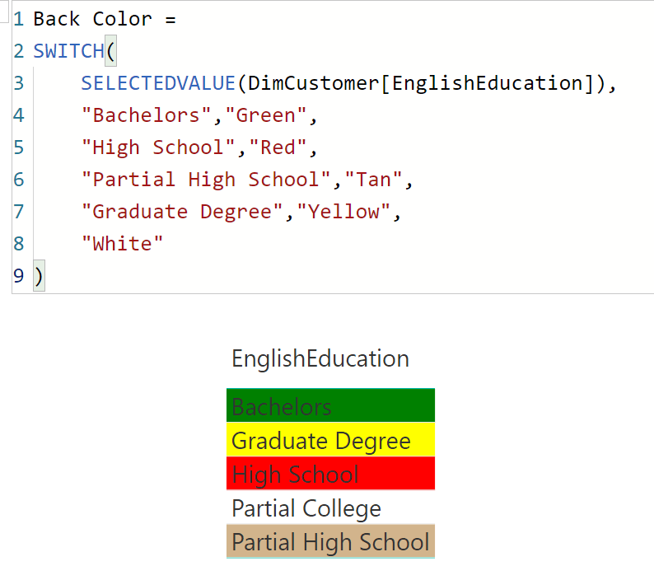

**3. Logical Operators**

* AND(cond1, cond2) → TRUE only if both are TRUE.
* OR(cond1, cond2) → TRUE if any one is TRUE.
* NOT(condition) → Reverses the result.

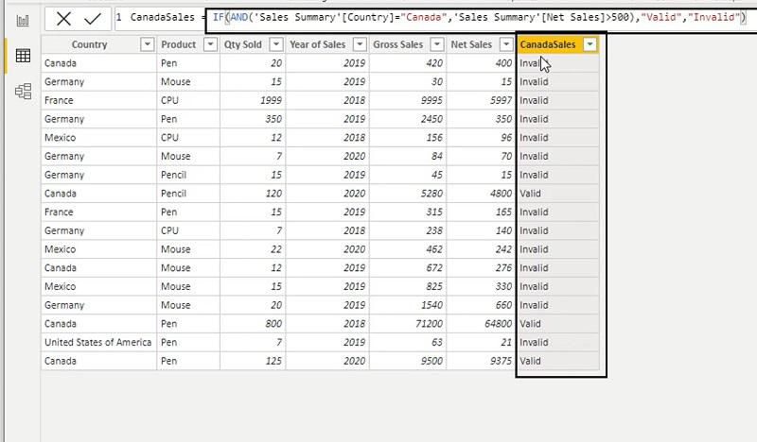

**4. Error Handling in DAX**

